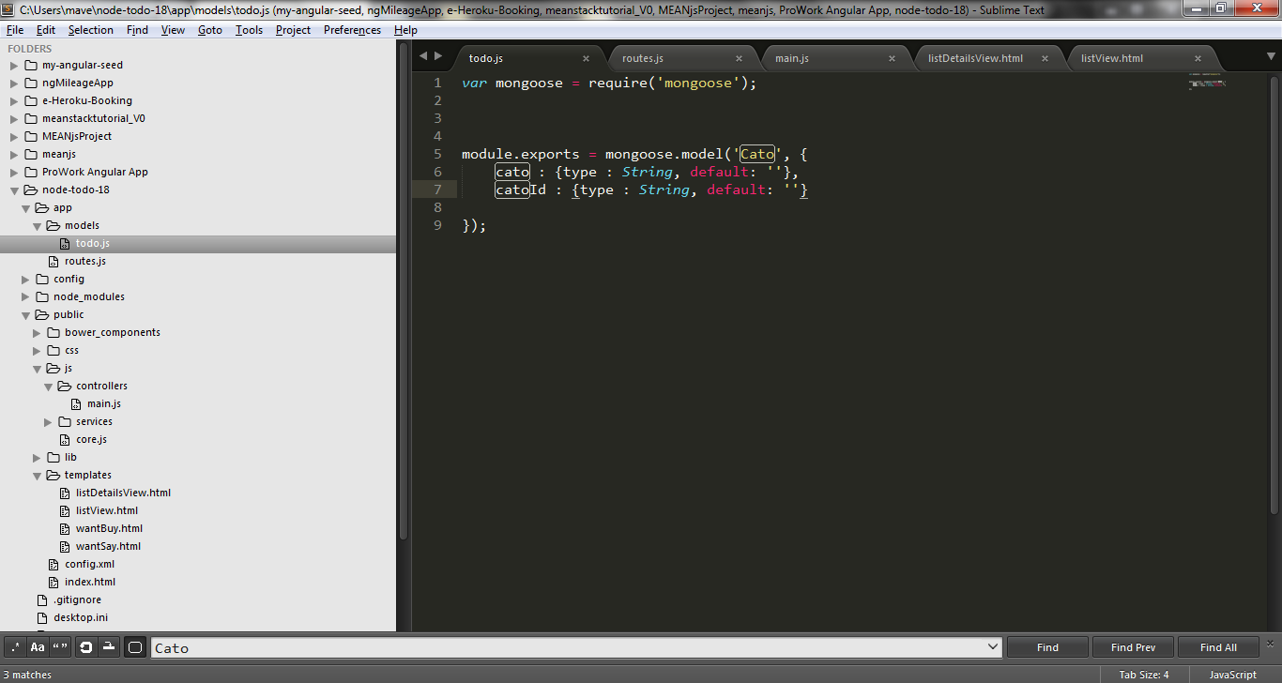

if catoId:{type: Number,default:’’}

then, cause the following error:

after you submit new pair of material, all lists gone!

